Personal Notes

**Date:** July 31, 2019 **Time:** 0930 **Location:** TBD

Attendees: Mr. Fontaine, Simona Babiceanu, Joseph Keogh

* **Plan (Where are we in the process)**

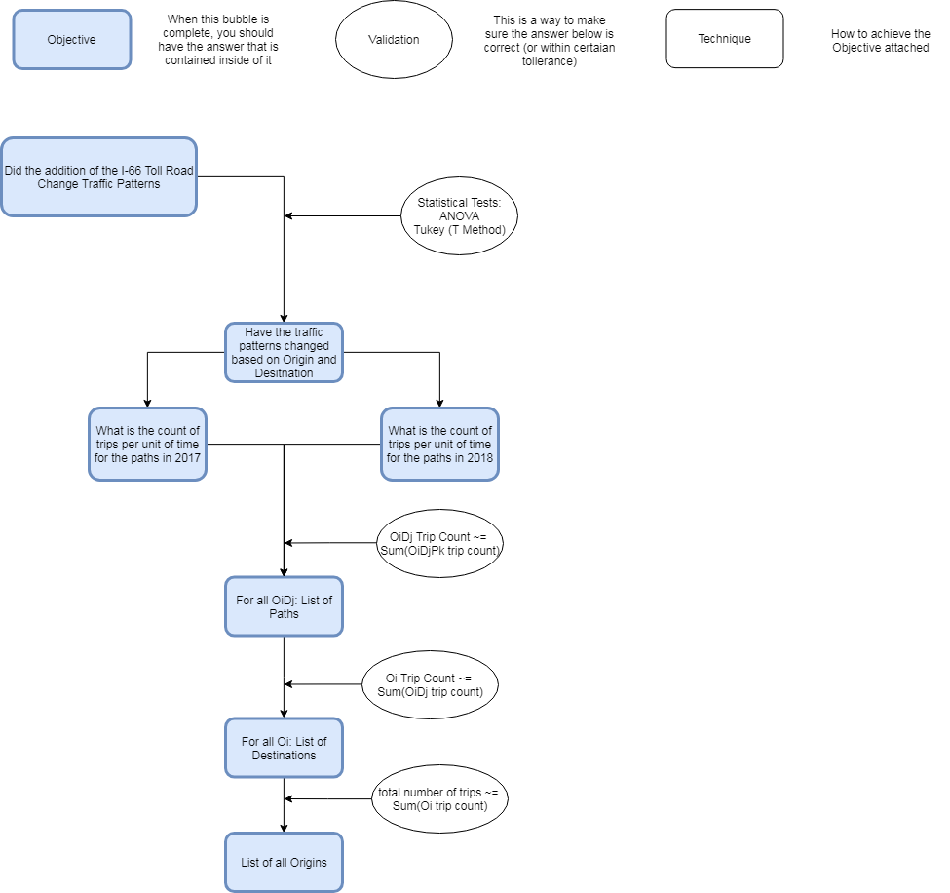



* Deliverables From Last Time
  + Methodology
  + Aggregate OD Nodes
  + Tableau
* Next Steps
  + Rerun program on Rivanna with new Trip to Path matching
  + Redo risk analysis with new Rivanna output
  + Stat analysis on new Rivanna output
  + For paper
    - Methodology
* Fontaine
  + Reduce hours?
    - Can just keep doing work
    - Charging hours for no reason
    - Do what I feel needs to be done
  + Work from home a couple days a week
    - You and Simona are gone
    - Just fleshing out details
    - See Family
  + Tableau Account Runs out tomorrow
    - IT?

Notes